Sprint 0 Product Brief

Error State (AlertBox and Inline Error) Screen Reader Accessibility Issue

### Problem Statement

Sometimes a user will attempt to move forward in a process without the prerequisite information provided. Or the selected information does not meet backend requirement needs and the user needs to be alerted as to the issue/requirement—in this situation, an AlertBox (and in some cases, inline errors above fields) appear. These alerts need to exist but also need to be screen reader accessible.

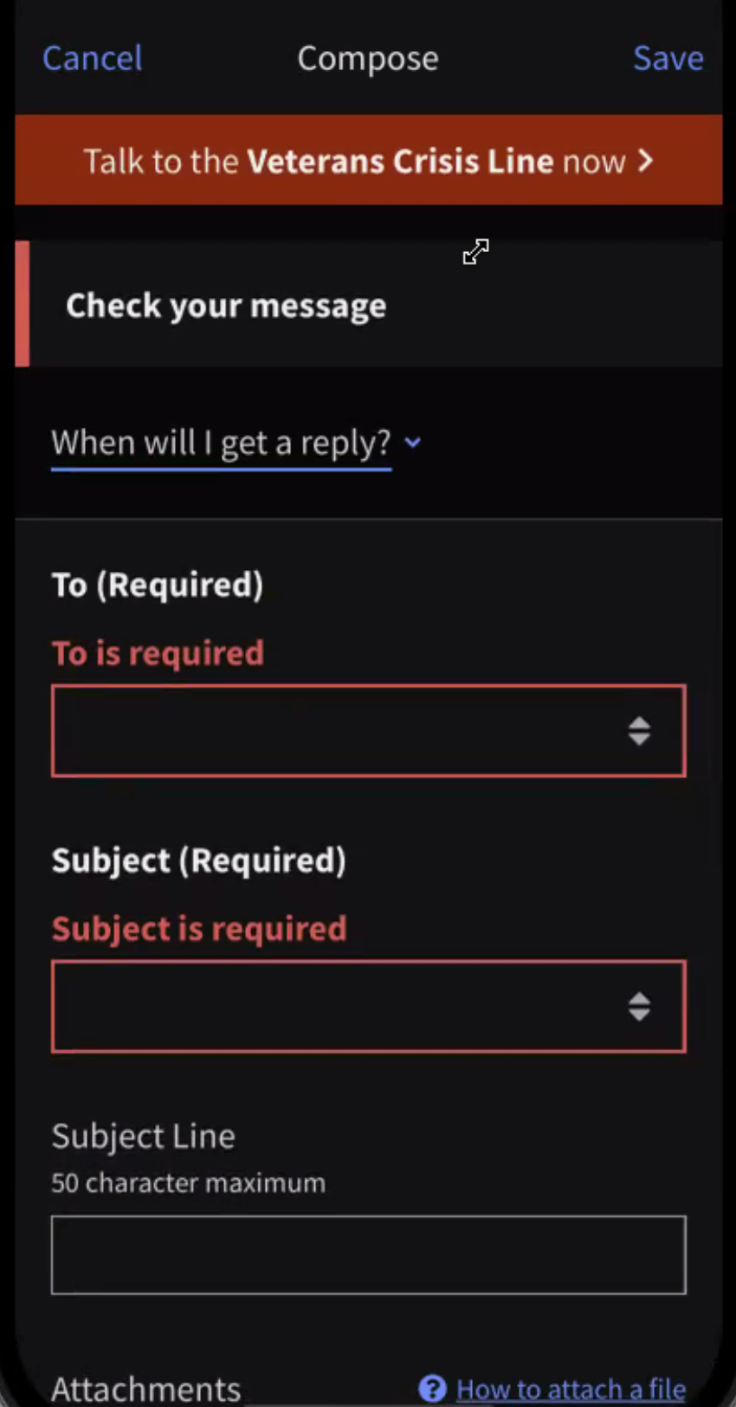

**Current Experience**

1. When an app user attempts to move forward in a process without the prerequisite information, we show an [AlertBox](https://department-of-veterans-affairs.github.io/va-mobile-app/docs/Engineering/FrontEnd/ComponentsSection/Alerts%20and%20Progress/AlertBox) to notify the user of an issue with their input or selection, but we do not focus with the screen reader (we don’t do anything!). In other words, the in-line alert we provide as a priority for sighted users is required to be discovered by a non-sighted one by swiping around the screen.
2. In addition we do not currently employ any AlertBox functionality for multiple missing fields to alert the user to, instead relying on them seeing the in-line errors on the screen.

**Pain Points**

* User doesn’t know why they can’t move forward without tapping around the screen.
* Current AlertBox messaging isn’t always terribly helpful in terms of indicating what’s needed from the user, and also doesn’t connect/suggest what the other inline errors are on the screen.

### Assumptions and Level of Confidence

1. A content audit for the content of the error messages displayed is NOT in scope for this effort.

### Risks

### 

### Business Goals

### Roadmap

**V1**

* v1 is 'announces the alert', all the right alerts

**V2 and beyond**

### Technical Approach

### Measuring success

### Stakeholders

### 

### Important Links

[VA Mobile Doc ite - AlertBox](https://department-of-veterans-affairs.github.io/va-mobile-app/docs/Engineering/FrontEnd/ComponentsSection/Alerts%20and%20Progress/AlertBox)